# Final Exam

# AI-Lab

# FA21-BCS-136

# ZAID ASGHAR VIRK

**QUESTION NO 1:**

**P1.**

**QUERY:**

Match (p:Person{name:'Tom Hanks'})-[r:DIRECTED]->(m:Movie) return p.name,m.title

**For the released year too:**

Match (p:Person{name:'Tom Hanks'})-[r:DIRECTED]->(m:Movie) return p.name,m.title,m.released

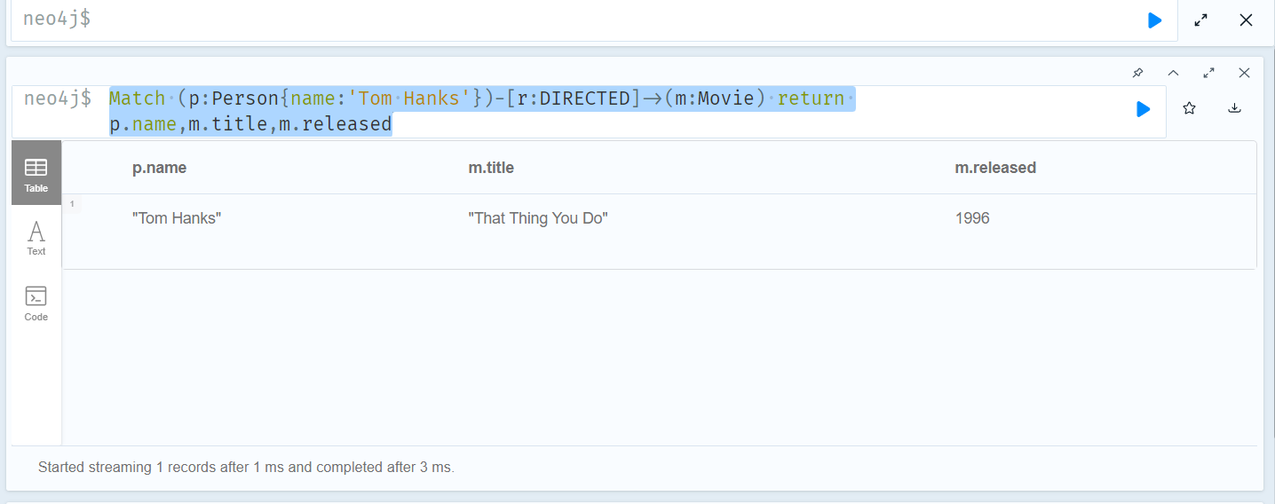

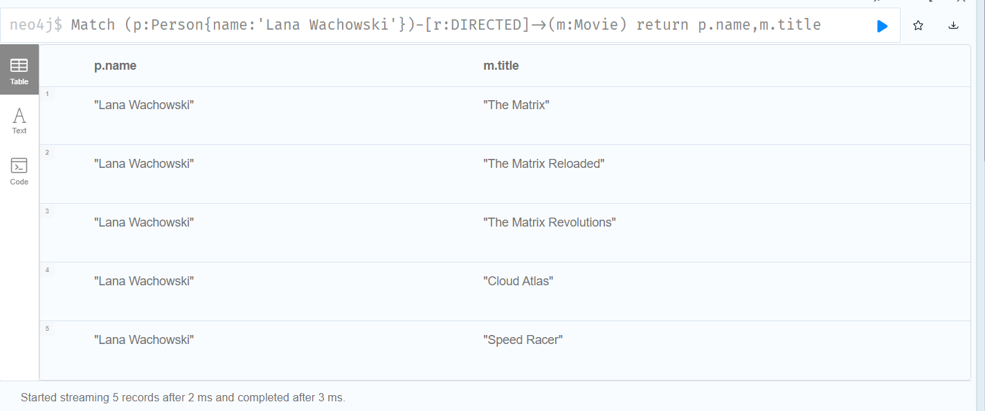

**P2:**

**Query:**

MATCH (p:Person)-[:DIRECTED]->(m:Movie)

WHERE m.released > 2000

RETURN m.title AS MovieTitle, p.name AS Director

**Explanation, Multiple Directors against each movie are being displayed.**

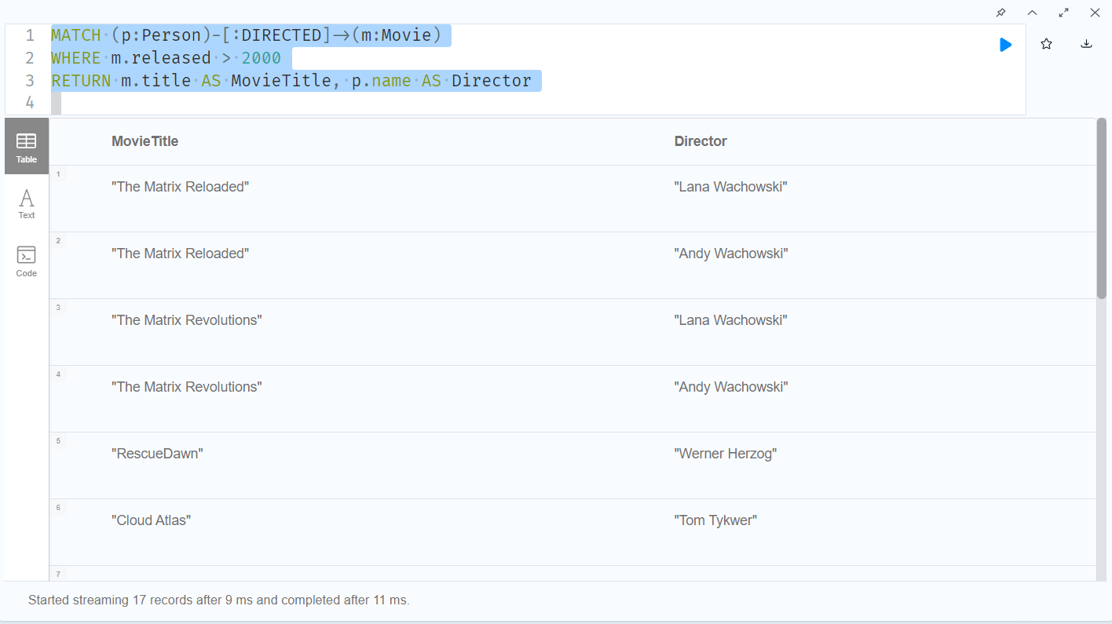

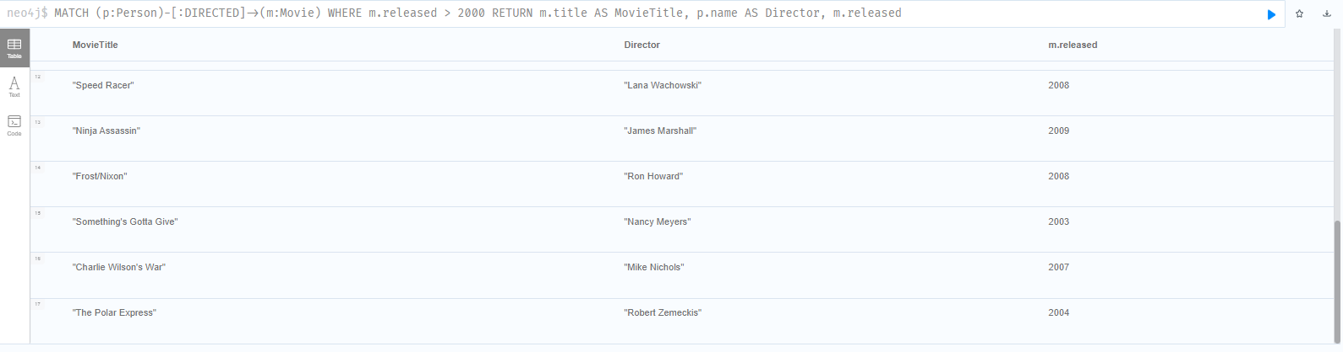

**To Print the name of directors as an array against each movie you can use:**

MATCH (p:Person)-[:DIRECTED]->(m:Movie)

WHERE m.released > 2000

RETURN m.title AS MovieTitle, collect(p.name) AS Director

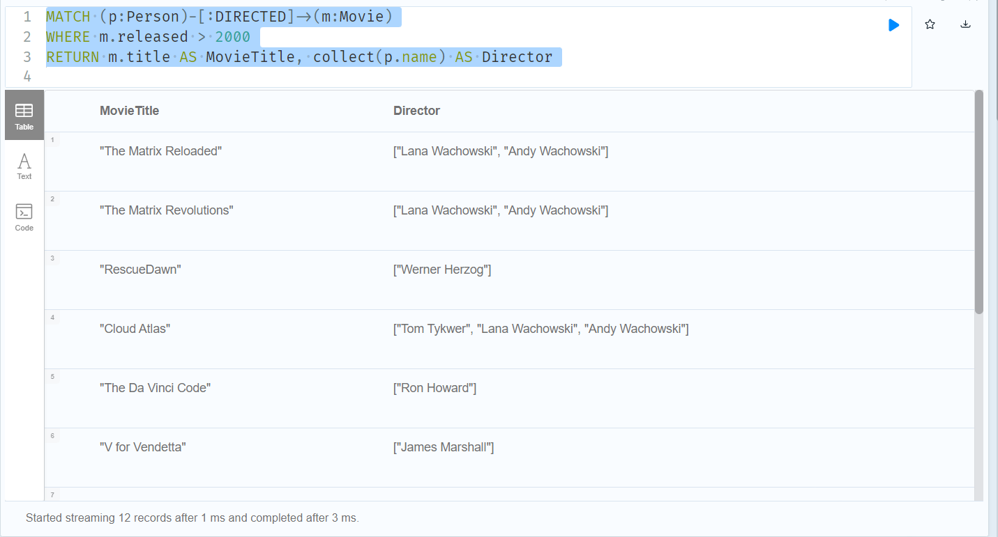

**P3:**

Query:

MATCH (p:Person)-[:ACTED_IN]->(m:Movie)

WITH p, COUNT(m.title) AS l

WHERE l >=3

RETURN p.name,l

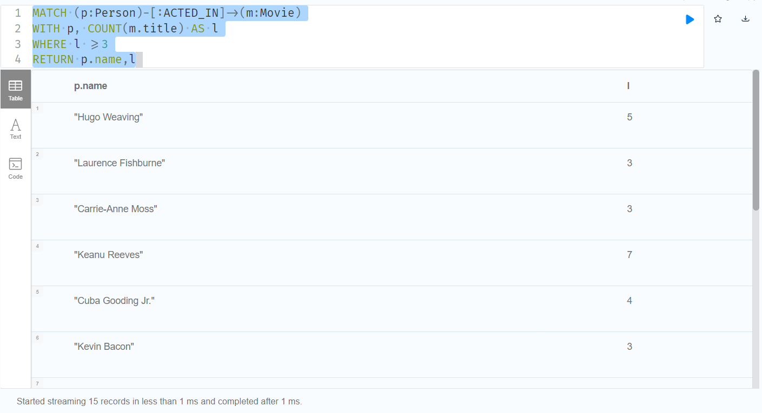

Also for sorting:

MATCH (p:Person)-[R:ACTED_IN]->(m:Movie) with p, count(m) as number where  number>=3 return p.name, number order by  number

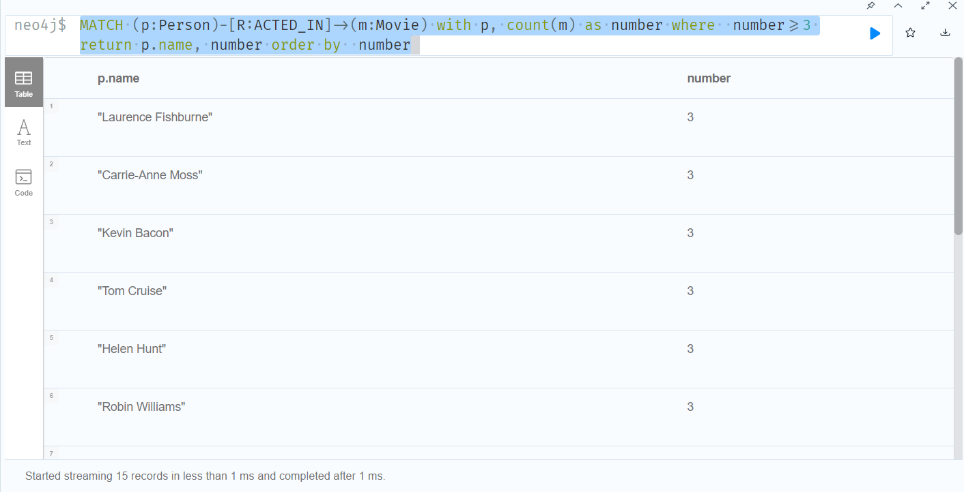

**P4:**

Query:

MATCH (p:Person{name:'Tom Hanks'})-[ACTED_IN]->(m:Movie)

OPTIONAL MATCH (m)<-[:PRODUCED]-(p1:Person)

OPTIONAL MATCH (m)<-[:ACTED_IN]-(p2:Person)

RETURN m.title, COLLECT(DISTINCT p1.name), COLLECT(DISTINCT p2.name)

No producers have been listed against movies tom hanks was actor in.

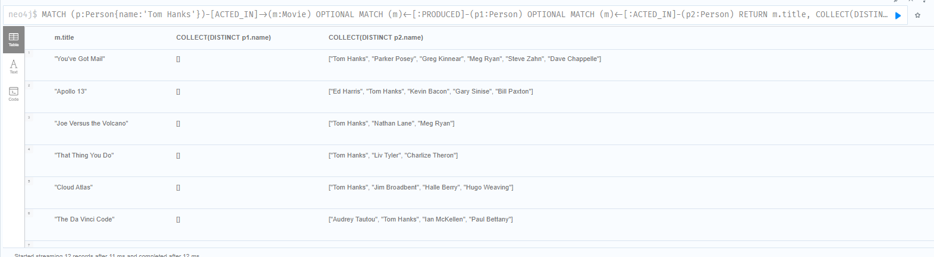

TO verify:

MATCH (p:Person{name:'Emil Eifrem'})-[ACTED_IN]->(m:Movie)

OPTIONAL MATCH (m)<-[:PRODUCED]-(p1:Person)

OPTIONAL MATCH (m)<-[:ACTED_IN]-(p2:Person)

RETURN m.title, COLLECT(DISTINCT p1.name), COLLECT(DISTINCT p2.name)

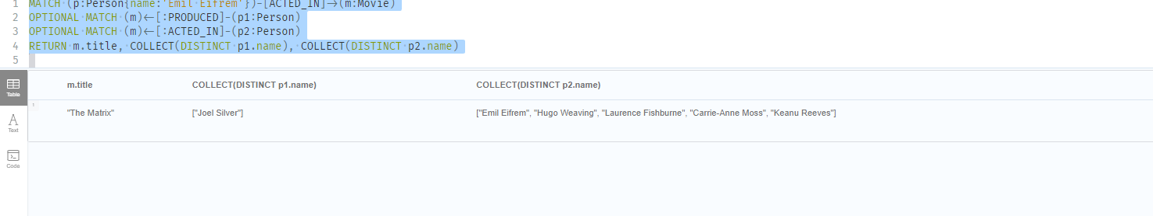

P4(Without Using Optional)

MATCh (n:Person{name:'Tom Hanks'})-[ACTED_IN]->(m:Movie)

MATCH (a:Person)-[:ACTED_IN]->(m)

MATCH (p:Person)-[:PRODUCED]->(m)

return m.title as movietitle, COLLECT(DISTINCT p.name) AS Producers,COLLECT(DISTINCT a.name) AS Actors

No producers have been listed against movies tom hanks was actor in.

To verify:

MATCh (n:Person)-[ACTED_IN]->(m:Movie)

MATCH (a:Person)-[:ACTED_IN]->(m)

MATCH (p:Person)-[:PRODUCED]->(m)

return m.title as movietitle, COLLECT(DISTINCT p.name) AS Producers,COLLECT(DISTINCT a.name) AS Actors

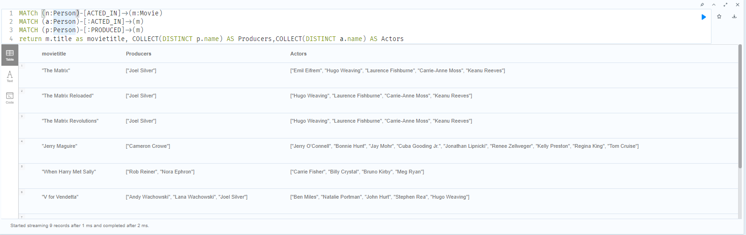

MATCh (n:Person{name:'Emil Eifrem'})-[ACTED_IN]->(m:Movie)

MATCH (a:Person)-[:ACTED_IN]->(m)

MATCH (p:Person)-[:PRODUCED]->(m)

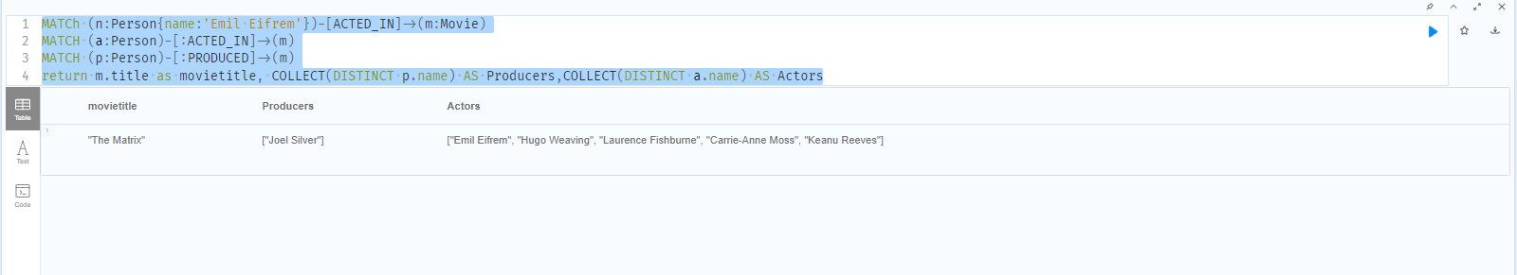return m.title as movietitle, COLLECT(DISTINCT p.name) AS Producers,COLLECT(DISTINCT a.name) AS Actors

P5:

MATCH (m:Movie)

DETACH DELETE m

# Question#2:

Code:

import random

#########################

Size_of_Population = 70

Mutation_Rate = 0.01

GENERATIONS = 1000

TARGET = 50

Error_Thresh_Hold = 2

#########################

def initialize_population1(size):

    population = []

    for _ in range(size):

        x = random.randint(0, TARGET)

        y = random.randint(0, TARGET)

        population.append((x, y))

    return population

#A better alternate using listcomprehension,

def initialize_population(size):

    return [(random.randint(0, TARGET), random.randint(0, TARGET)) for _ in range(size)]

def fitness(individual):

    x, y = individual

    return abs(3*x + 2*y - TARGET)

def parent_selection(population):

    tournament_size = 5

    selected = random.sample(population, tournament_size)

    selected.sort(key=fitness)

    return selected[0], selected[1]

#Crossover

def crossover(parent1, parent2):

    x1, y1 = parent1

    x2, y2 = parent2

    child1 = (x1, y2)

    child2 = (x2, y1)

    return child1, child2

def mutaion(individual):

    x, y = individual

    if random.random() < Mutation_Rate:

        x = random.randint(0, 50)

    if random.random() < Mutation_Rate:

        y = random.randint(0, 50)

    return (x, y)

def next_generation(current_population):

    new_pop = []

    for _ in range(Size_of_Population // 2):

        parent1, parent2 = parent_selection(current_population)

        child1, child2 = crossover(parent1, parent2)

        child1 = mutaion(child1)

        child2 = mutaion(child2)

        new_pop.append(child1)

        new_pop.append(child2)

    return new_pop

#genteic algorithm

def geneti_algo():

    population = initialize_population(Size_of_Population)

    for generation in range(GENERATIONS):

        population.sort(key=fitness)

        best_individual = population[0]

        best_fitness = fitness(best_individual)

        ###Question2,last part Conversion check###

        if best_fitness < Error_Thresh_Hold:

            return best_individual, generation

        population = next_generation(population)

    population.sort(key=fitness)

    return population[0], GENERATIONS

solution, generations = geneti_algo()

print(f"Solution: x = {solution[0]}, y = {solution[1]} after {generations} generations.")

OUTPUT:

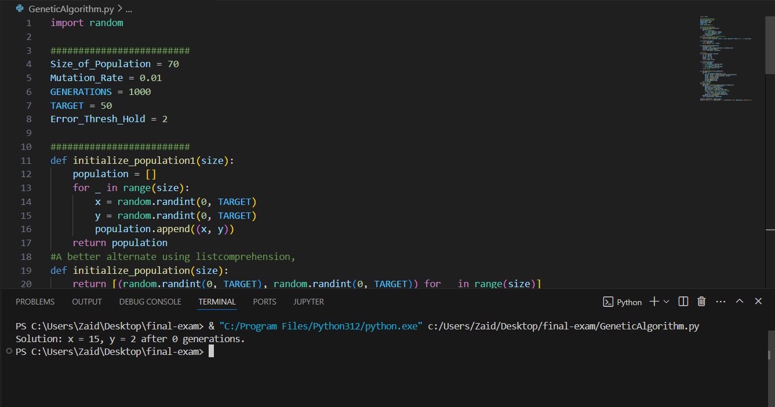

**Changing Parameters 1:**

Size_of_Population = 10

Mutation_Rate = 0.01

GENERATIONS = 100

TARGET = 50

Error_Thresh_Hold = 2

OUTPUT:

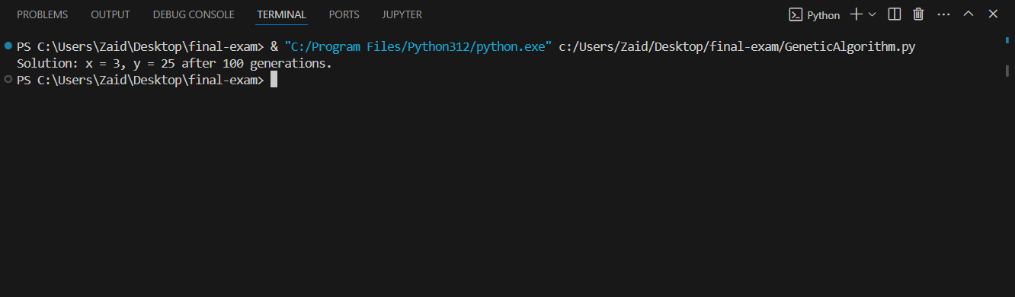

**Question NO 3:**

import pandas as pd

from sklearn.model_selection import train_test_split

from sklearn.linear_model import LinearRegression

from sklearn.metrics import mean_absolute_error, mean_squared_error, r2_score

import numpy as np

df = pd.read_csv('./Datasetfile/FuelConsumptionCo2.csv')

print(df.head())

X = df[['ENGINESIZE']]

y = df['CO2EMISSIONS']

X_train, X_test, y_train, y_test = train_test_split(X, y, test_size=0.2, random_state=42)

model = LinearRegression()

model.fit(X_train, y_train)

intercept = model.intercept_

coefficients = model.coef_

print(f'Intercept: {intercept}')

print(f'Coefficients: {coefficients}')

enginecc=2.5

engine_size = pd.DataFrame([[enginecc]], columns=['ENGINESIZE'])

predicted_CO2 = model.predict(engine_size)

print(f'Predicted CO2 emissions for a vehicle with a {enginecc}-liter engine: {predicted_CO2[0]}')

y_pred = model.predict(X_test)

mae = mean_absolute_error(y_test, y_pred)

mse = mean_squared_error(y_test, y_pred)

r2 = r2_score(y_test, y_pred)

print(f'Mean Absolute Error (MAE): {mae}')

print(f'Mean Squared Error (MSE): {mse}')

print(f'R-squared (R2): {r2}')

Output:

